**DATA CLEANING PROJECT**

**1.Total Employees**

SELECT COUNT(*) AS Total_Employess FROM HR;

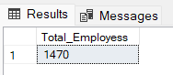

**2.Active Employees**

SELECT COUNT(*) AS Active_Employees FROM HR WHERE Attrition = 0;

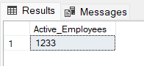

**3.Attrition Employees**

SELECT COUNT(*) AS Total_Employees_Attrition FROM HR WHERE Attrition = 1;

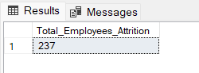

**4.Gender Distribution of Active Employees**

SELECT Gender, COUNT(*) AS Employees FROM HR WHERE Attrition = 0 GROUP BY Gender;

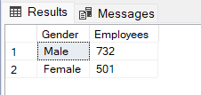

**5.Age distribution of Employees**

SELECT

CASE

WHEN Age BETWEEN 18 AND 23 THEN '18-23'

WHEN Age BETWEEN 24 AND 29 THEN '24-29'

WHEN Age BETWEEN 30 AND 35 THEN '30-35'

WHEN Age BETWEEN 36 AND 41 THEN '36-41'

WHEN Age BETWEEN 42 AND 47 THEN '42-47'

WHEN Age BETWEEN 48 AND 60 THEN '48-60'

ELSE '60+'

END AS Age_group,COUNT(Age) AS Employees_Count

FROM HR

GROUP BY

CASE

WHEN Age BETWEEN 18 AND 23 THEN '18-23'

WHEN Age BETWEEN 24 AND 29 THEN '24-29'

WHEN Age BETWEEN 30 AND 35 THEN '30-35'

WHEN Age BETWEEN 36 AND 41 THEN '36-41'

WHEN Age BETWEEN 42 AND 47 THEN '42-47'

WHEN Age BETWEEN 48 AND 60 THEN '48-60'

ELSE '60+'

END

ORDER BY Age_group;

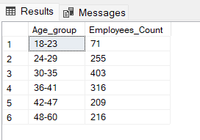

**6.Attrition trends by Age Group**

SELECT

CASE

WHEN Age BETWEEN 18 AND 23 THEN '18-23'

WHEN Age BETWEEN 24 AND 29 THEN '24-29'

WHEN Age BETWEEN 30 AND 35 THEN '30-35'

WHEN Age BETWEEN 36 AND 41 THEN '36-41'

WHEN Age BETWEEN 42 AND 47 THEN '42-47'

WHEN Age BETWEEN 48 AND 60 THEN '48-60'

ELSE '60+'

END AS Age_Group,

COUNT(CASE WHEN Attrition = 1 THEN 'Yes' END) AS Attrition_Yes,

COUNT(CASE WHEN Attrition = 0 THEN 'No' END) AS Attrition_No

FROM HR

GROUP BY

CASE

WHEN Age BETWEEN 18 AND 23 THEN '18-23'

WHEN Age BETWEEN 24 AND 29 THEN '24-29'

WHEN Age BETWEEN 30 AND 35 THEN '30-35'

WHEN Age BETWEEN 36 AND 41 THEN '36-41'

WHEN Age BETWEEN 42 AND 47 THEN '42-47'

WHEN Age BETWEEN 48 AND 60 THEN '48-60'

ELSE '60+'

END

ORDER BY Age_Group;

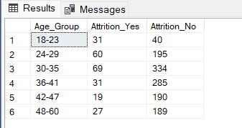

**7.Gender Attrition Analysis**

SELECT Gender, COUNT(*) AS Employees FROM HR WHERE Attrition = 1 GROUP BY Gender ORDER BY COUNT(*) DESC;

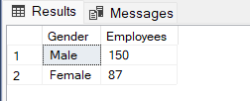

**8.Employees Active and Attrition by Department**

SELECT Department,

COUNT(CASE WHEN Attrition = 1 THEN 'Yes' END) AS Attrition_Yes,

COUNT(CASE WHEN Attrition = 0 THEN 'No' END) AS Attrition_No

FROM HR

GROUP BY Department

ORDER BY COUNT(Attrition);

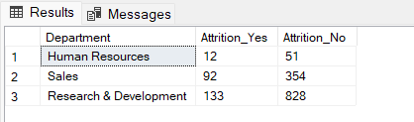

**9.Education Field by Employees**

SELECT EducationField, COUNT(Attrition) AS Employees

FROM HR

GROUP BY EducationField

ORDER BY COUNT(Attrition);

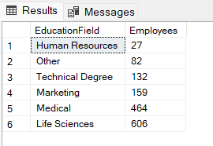

**10.Impact of Education on Employees Turnover**

SELECT EducationField,

COUNT(CASE WHEN Attrition = 1 THEN 'Yes' END) AS Attrition_Yes,

COUNT(CASE WHEN Attrition = 0 THEN 'No' END) AS Attrition_No

FROM HR

GROUP BY EducationField

ORDER BY COUNT(Attrition);

**11.Employees by Job Level**

SELECT JobLevel,COUNT(Attrition) AS Employees

FROM HR

GROUP BY JobLevel

ORDER BY COUNT(Attrition);

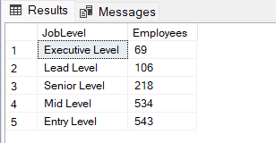

**12.Attrition Trends Across Different job levels**

SELECT JobLevel,

COUNT(CASE WHEN Attrition = 1 THEN 'Yes' END) AS Attrition_Yes,

COUNT(CASE WHEN Attrition = 0 THEN 'No' END) AS Attrition_No

FROM HR

GROUP BY JobLevel

ORDER BY COUNT(Attrition);

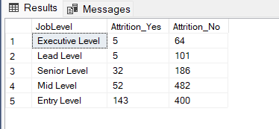

**13.Employees by Job Roles**

SELECT JobRole,COUNT(Attrition) AS Employees

FROM HR

GROUP BY JobRole

ORDER BY COUNT(Attrition);

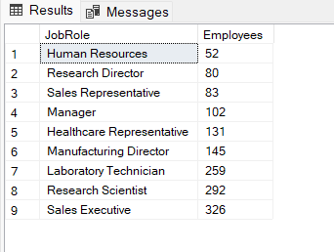

**14.Analyzing Departures by Job Roles**

SELECT JobRole,

COUNT(CASE WHEN Attrition = 1 THEN 'Yes' END) AS Attrition_Yes,

COUNT(CASE WHEN Attrition = 0 THEN 'No' END) AS Attrition_No

FROM HR

GROUP BY JobRole

ORDER BY COUNT(Attrition);

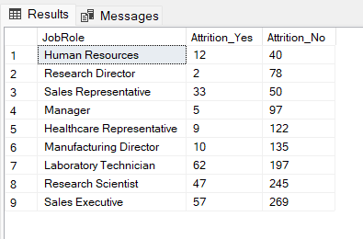

**15.Marital Status Insights**

SELECT MaritalStatus,

COUNT(CASE WHEN Attrition = 1 THEN 'Yes' END) AS Attrition_Yes,

COUNT(CASE WHEN Attrition = 0 THEN 'No' END) AS Attrition_No

FROM HR

GROUP BY MaritalStatus

ORDER BY COUNT(Attrition);

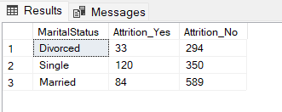

**16.Attrition by Years of Service**

SELECT

CASE

WHEN YearsAtCompany BETWEEN 0 AND 7 THEN '0-7'

WHEN YearsAtCompany BETWEEN 8 AND 15 THEN '8-15'

WHEN YearsAtCompany BETWEEN 16 AND 23 THEN '16-23'

WHEN YearsAtCompany BETWEEN 24 AND 31 THEN '24-31'

ELSE '32-40'

END AS Years_Group,

COUNT(CASE WHEN Attrition = 1 THEN 'Yes' END) AS Attrition_Yes,

COUNT(CASE WHEN Attrition = 0 THEN 'No' END) AS Attrition_No

FROM HR

GROUP BY CASE

WHEN YearsAtCompany BETWEEN 0 AND 7 THEN '0-7'

WHEN YearsAtCompany BETWEEN 8 AND 15 THEN '8-15'

WHEN YearsAtCompany BETWEEN 16 AND 23 THEN '16-23'

WHEN YearsAtCompany BETWEEN 24 AND 31 THEN '24-31'

ELSE '32-40'

END

ORDER BY Years_Group;

